**Sheet1**

1. The following 4x6 digital image is of 3-bit amplitude resolution.
2. What is the negative image of this one.

b) How to get the histogram of that image? What information does it carry?

d) Enhance the image by equalizing its histogram simultaneously. The allowable gray levels of this image is {0,1,2..7}.



1. Perform the following filters on the shaded pixels of 5 X 5 image below:
   1. Average Filter
   2. Median Filter

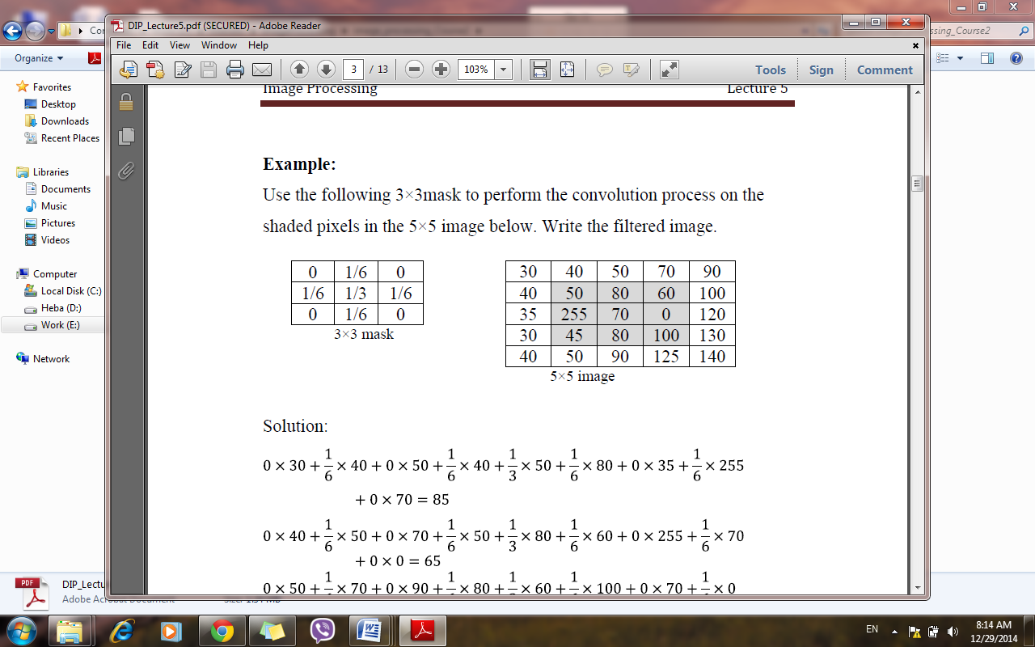

1. A 4x4 image is given as follow. The image is transformed using the point transform shown.

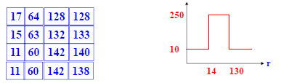

a) Find the pixel values of the output image.

b) What is the 7-th bit plane of this image?

1. Consider the image segment shown below.

(a) Let V = {0, 1} and compute D4-, D8,Dm-distances between p and q.

(b) Repeat for V = {1, 2}.

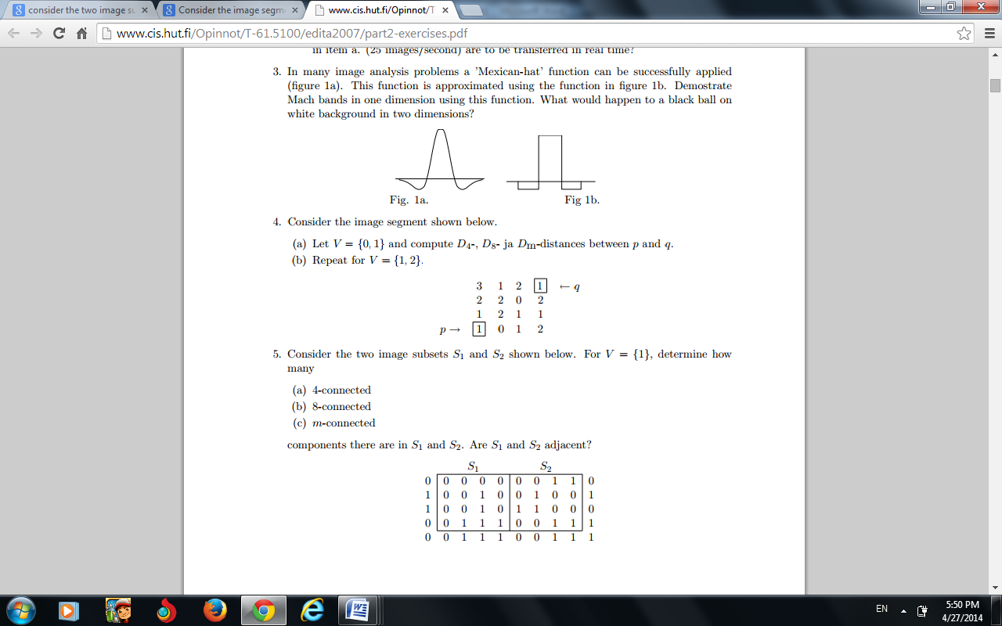

1. Consider the two image subsets S1 and S2 shown below. For V = {1}, determine whether these two subsets are (a) 4-adjacent (b) 8-adjacent and explain

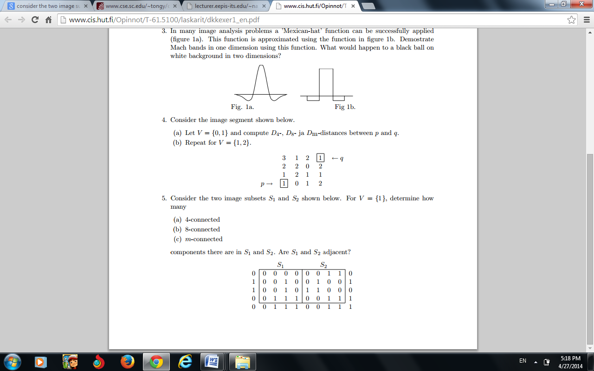

1. Equalize the histogram of the 8 × 8 image below. The image has grey levels 0, 1, . . . ,7.

|  |  |
| --- | --- |
|  | 4 4 4 4 4 4 4 0  4 5 5 5 5 5 4 0  4 5 6 6 6 5 4 0  4 5 6 7 6 5 4 0  4 5 6 6 6 5 4 0  4 5 5 5 5 5 4 0  4 4 4 4 4 4 4 0  4 4 4 4 4 4 4 0 |

1. Perform histogram equalization given the following histogram.

(r = Gray level, n = number of occurrences)

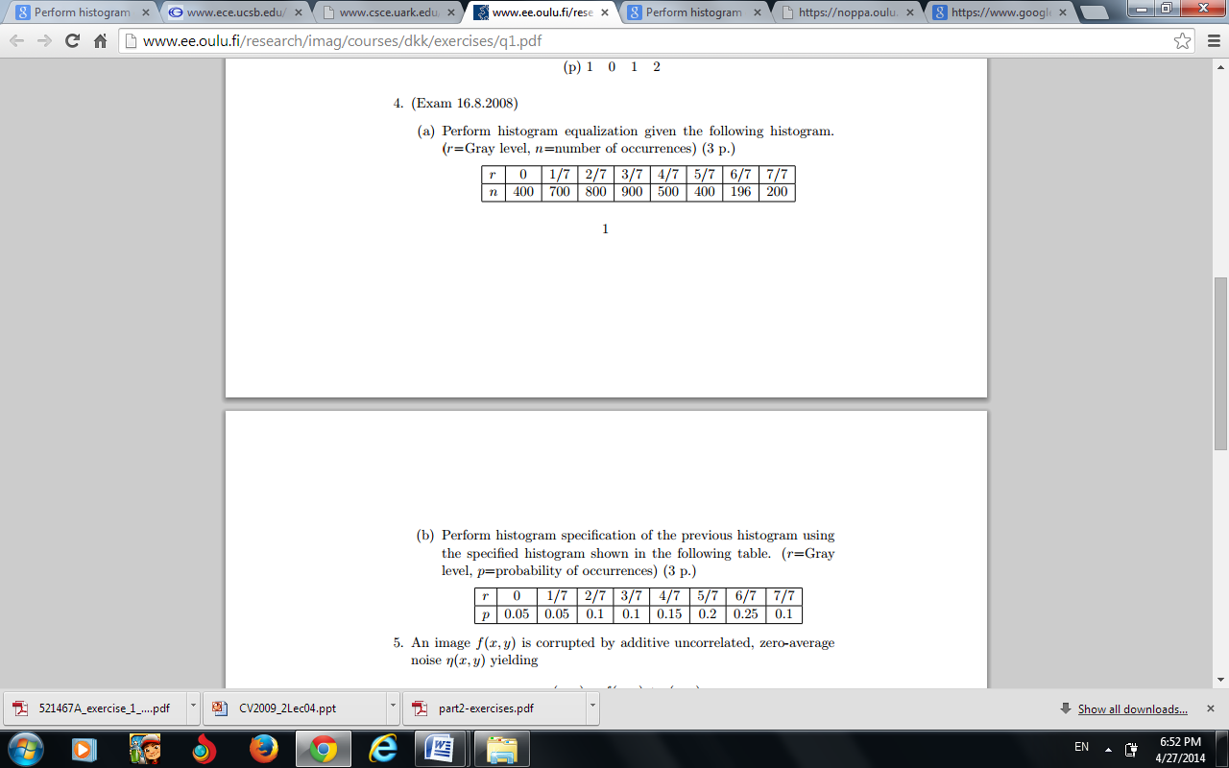

1. Perform histogram specification of the previous histogram using the specified histogram shown in the following table. (r=Gray level, p=probability of occurrences



1. Describe the following histogram and match with corresponding image

|  |  |  |  |
| --- | --- | --- | --- |
| (a) | (b) | (c) | (d) |
| (1) | (2) | (3) | (4) |